# Evidence for Analysis and Design Unit

Simon Atkins

Cohort e20

## A.D.1 Use case Diagram

Animal shelter system use case

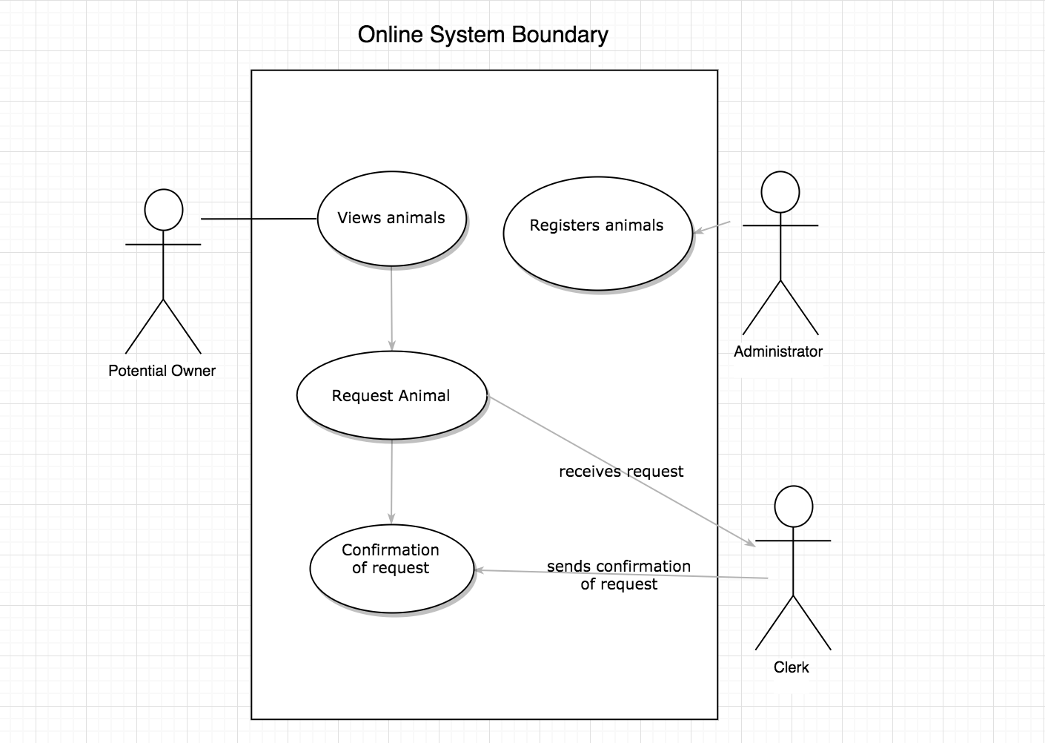

## A.D.2 Class Diagram

**Internet Troll Adoption Center**

Each class includes CRUD methods

Owner requires a Troll

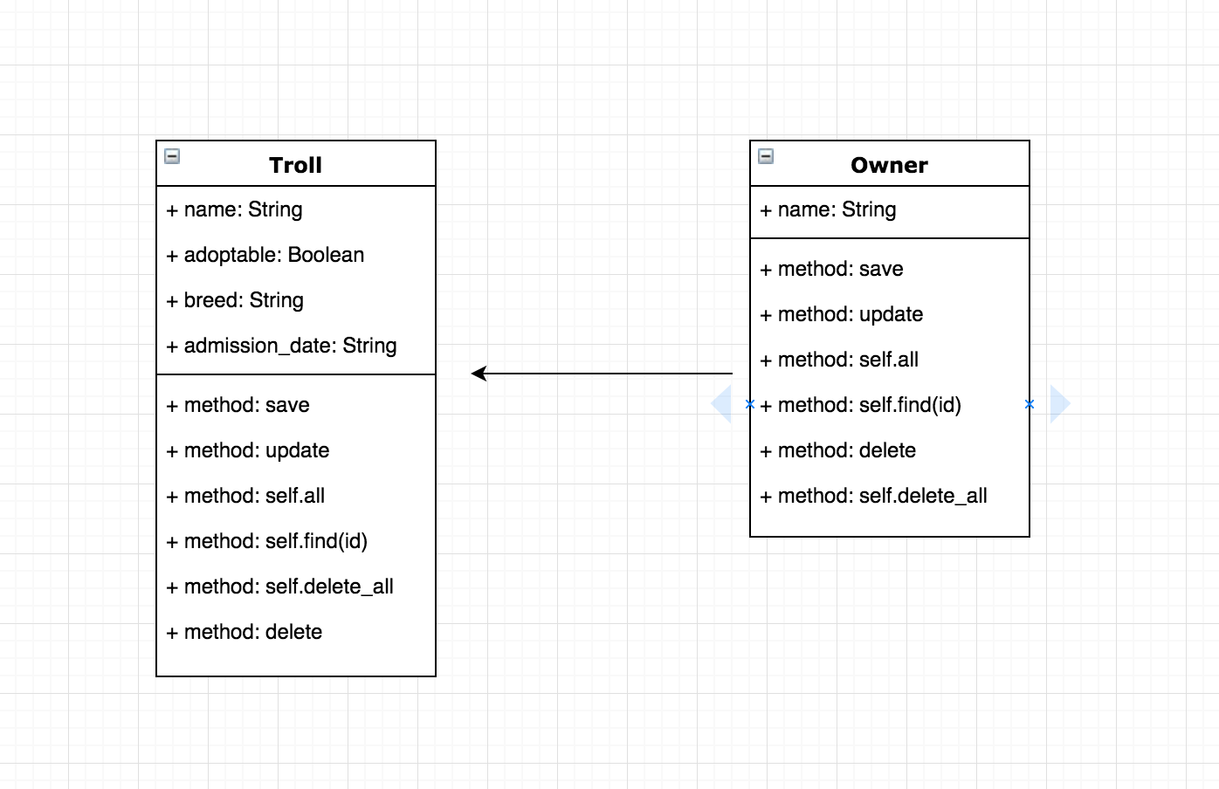

## A.D.3 Object Diagram

**Internet Troll Adoption Center**

One-to-many: An Owner can have many Trolls but a Troll can only have one Owner

The owner_id field for each Troll references the primary key of an Owner

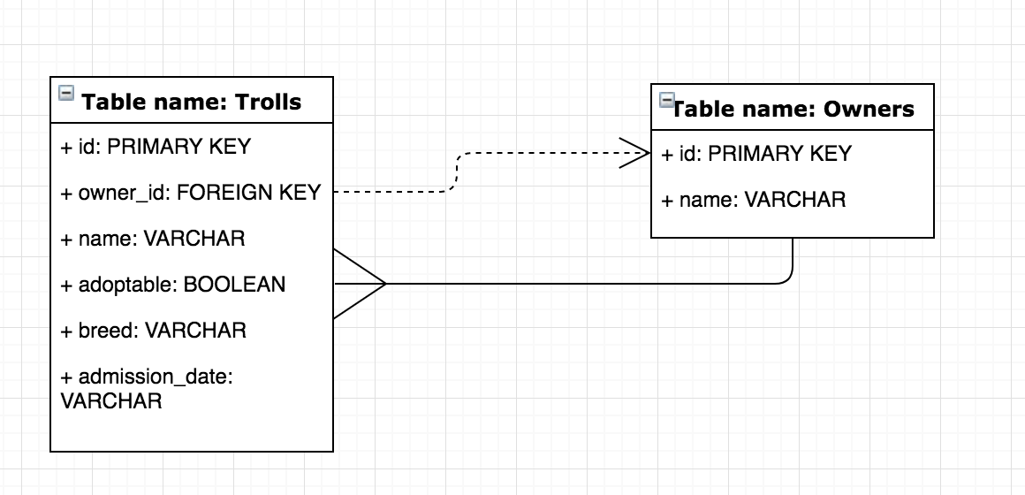

## A.D.4 Activity Diagram

User enters site to update Owner for a Troll in Troll Shelter project.

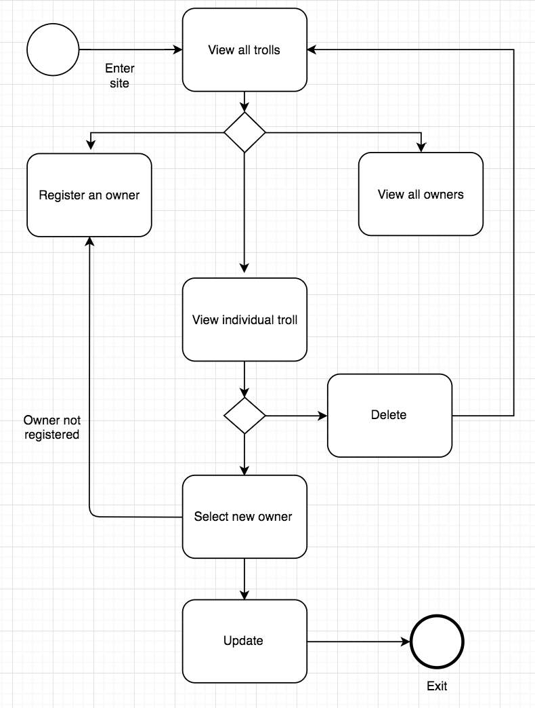

## A.D.5 Inheritance Diagram

## A.D.6 Implementation Constraints

### Hardware and Software Platforms

**Constraints and possible effect:** Slow, outdated hardware and software for example can make it difficult for developers to quickly develop the software. User hardware and software constraints can mean they aren’t able to view a site or process the amount of information.

**Solution:** Employers should ensure that hardware and software meets standard requirements for developers. Regarding users, developers should agree on a benchmark for what the reasonable minimum requirements are that can be expected of a user, before building the software.

### Performance Requirements

**Constraints and possible effect:** Potential slow performance due to having too much logic in the Controller files of the app, for example.

**Solution:** Refactor code so that logic takes place at the database level through SQL queries instead of Ruby logic in the Controller files.

### Persistent Storage and Transactions

**Constraints and possible effect:** Potential issues with storage space for large amounts of information as well as security of personal data.

**Solution:** Ensure that all personal data is correctly encrypted, purchase enough database storage from third parties, and delete data older than a certain number of years.

### Budgets

**Constraints and possible effect:** Budget constraints often means fewer staff members than necessary and/or unsatisfactory equipment needed for project completion.

**Solution:** A greater budget allocation via senior management or increased funding from external partners.

### Time

**Constraints and possible effect:** Time constraints can mean that developers are overworked, and that features of the software are negatively affected.

**Solution:** Developers and their managers may have to discuss time constraints with stakeholders and negotiate what features of the software should take priority so as to reach an MVP.